Biometrics4ALL Procedure Series

Google Locations Project

|  |  |
| --- | --- |
|  | Logo with Reflection_Low_Res |
|  |  |

|  |
| --- |
| Legal Disclaimer: This document is protected by copyright laws and is for Biometrics4ALL’s internal use only. Unauthorized duplication and/or distribution are strictly prohibited and will be prosecuted to the maximum extent of the law. |

Revision History

|  |  |  |  |
| --- | --- | --- | --- |
| **Date** | **Version** | **Notes** | **Author** |
| July 3rd, 2023 | 1.0.0 | Initial Draft | Mekaeel Ahmad |
|  |  |  |  |
|  |  |  |  |
|  |  |  |  |
|  |  |  |  |
|  |  |  |  |
|  |  |  |  |

# Preface: Information on the Project and a HIGH-LEVEL overview

At the moment, the goal of this project is to have all of our member locations shown on Google as ApplicantServices.com locations. For example, if we have a The UPS Store #XXXX as a Service Affiliate Member, on Google Maps we would like to have that location shown as “**ApplicantServices.com dbw The UPS Store #XXXX**”. This location would include the proper business hours, appropriate address from the maintenance sheet, the primary phone as the member’s phone number from the maintenance sheet, the secondary phone as our phone number, and be listed under the category “Fingerprinting Service”. These will all be fulfilled by following Google’s bulk location spreadsheet template. Additionally, when an individual searches for the keyword “livescan”, “fingerprinting”, or “livescan fingerprinting” this location should be shown on Google. This entire project revolves around this file and using the Maintenance Excel File to properly input information for Google’s template. More information on Google’s bulk spreadsheet can be found at this link: <https://support.google.com/business/answer/3370250?hl=en>.

For this to work, we must upload an Excel File (which will we will create in the following procedures) into Google Business Profile Manager. Go to [biometrics4all@gmail.com’s](mailto:biometrics4all@gmail.com’s) Google Business Profile Manager which looks like the page below. In the Main menu (follow picture below) click “Add business”, “Import businesses”, and select the Excel File that we created. The following Procedures will teach you how to make that Excel File.

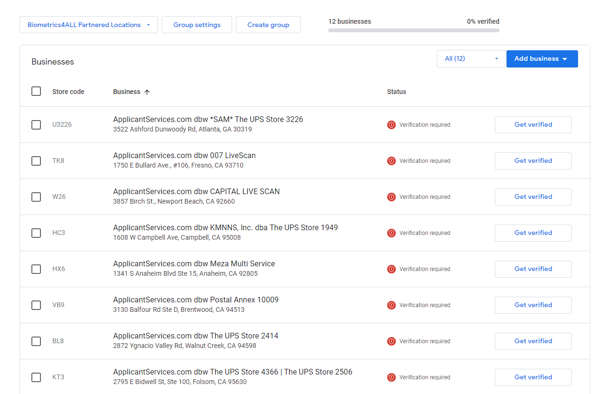

# Preparation - REQUIREd Tools

* 1. ***Have Updated Python Downloaded.***

In order to complete this task, you need to make sure that you have Python installed on your computer. You can download python by visiting <https://www.python.org/downloads/windows/>. When you click the link, download the latest embeddable package (64-bit) for windows and the install it using the Windows Installer (64-bit).

If you already have it installed, make sure that it is up to date. You can check your Python version by opening your terminal and typing: **“py –version”.** Make sure that your Python version is above 3.9.0. Here is an example:



\*\*If this doesn’t work, your Operating System doesn’t recognize “py” as python. In this case, type in “python3 –version” or “python –version”.

* 1. ***Have the Python Packages Pandas and Openpyxl Installed***

You can do this by typing “**pip install pandas openpyxl**” in your terminal.



\*\*If this doesn’t work, once again, your OS isn’t recognizing your command. Pip is a package-management system used to install and manage software packages written in python. In this case, you should type, “**py -m pip install pandas openpyxl**” or “**python -m pip install pandas openpyxl**”



* 1. ***Have access to the Sales Drive, the most updated MaintenanceSheet Excel file, and Business Hours file.***

**Make sure you have access to the Sales Drive Folder, specifically, the file-path: “Google Location Project\Step-by-step”.** Additionally, you should have access to the most updated version of the Maintenance Excel File that is completely unfiltered. You should also have access to the most updated version of the Business Hours file, which contains all of our locations and their business hours.

# Procedures to properly format and Understand Locations.xlsx

* 1. ***Correctly formatting the sheet, MaintenanceSheet in Locations.xlsx***

**DISCLAIMER: MAKE SURE YOU DON’T EDIT ANY OF THE SHEET NAMES IN LOCATIONS.XLSX.**

To begin, open up the most updated Maintenance Excel File. Once you do that, filter the businesses that Edward would like to be shown on Google. For example, make sure that maintenance is up to date or if businesses are in Network. In my case, I filtered the Maintenance Excel File with locations that were InNetwork, Active, and under Maintenance.

Once you have the businesses filtered in the most updated Maintenance Excel File, open up Locations.xlsx. Make sure that the existing columns of the sheet in Locations.xlsx called “MaintenenceSheet” and the columns of the filtered businesses in the Maintenance Excel file are the same. Now, copy all the values of the filtered businesses in the Maintenance Excel File and paste their values (to paste their values right click, go to Paste Options, and click Values (V)). **If you don’t paste their values, you will be pasting the code that is listed for each cell.**



* 1. ***Understanding Hours Sheet and how to use it.***

**Open the most updated version of the Business Hours file. Make sure that the columns A-Q of this Business Hours file align with the columns A-Q of the sheet called “Hours Sheet” in Locations.xlsx. Once you’ve recognized that they are the same, copy columns A-Q of the Business Hours file and paste with values into columns A-Q of the Hours Sheet (once again,** to paste their values right click, go to Paste Options, and click Values). Columns A-Q of the Hours Sheet should be filled and column S is responsible for filtering the business hours to only show businesses in the sheet “MaintenenceSheet”. You can filter this by filtering for “Yes”.

Now that the “Hours Sheet” in Locations.xlsx contains only the business hours from businesses in MaintenenceSheet, copy everything in the Hours Sheet completely (every column) and paste the values into the next sheet called “hours” in the same Excel file.

**DISCLAIMER: Make sure the Store Hours column is in column P of the ‘hours’ sheet. And that Sunday-Monday are in columns W-AC respectively.**

Now that this is finished, there are extra procedures that you need to do because of bad data. Go to column P of the “hours” sheet and highlight it. As it is highlighted type “Ctrl + F” and replace “</br>” with Ctrl + J (the replace input should look like a blinking dot like the picture below). These </br>’s represent HTML line breaks from the original data source. Ctrl + J creates Excel’s newline character. Now, this fix is a solution to the following example.

Something like:

**M-F:9am-6:30pm</br>Sa:10am-11:30am,2pm-4pm**

Now becomes:

**M-F:9am-6:30pm**

**Sa:10am-11:30am,2pm-4pm**

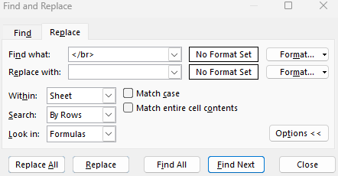

.



**Once you’re done with this, close the excel file and move on to the next step.**

* 1. ***Using googleLocations.py***

**DISCLAIMER: MAKE SURE THAT googleLocations.py IS IN THE SAME FOLDER AS Locations.xlsx. This should already be done for you in the Sales folder. Make sure that there are no filters applied to anything in the** MaintenenceSheet **or in** hours **sheet in** Locations.xlsx **(you can check this if there are no blue numbers on the left-most column)**

**Once Locations.xlsx is saved and closed, open your terminal and type the command to run the python program. When you type this, you need to make sure that you are in the folder that contains googleLocations.py and Locations.py. You can open this in terminal by going to file explorer and right clicking “Open in Terminal”.**

**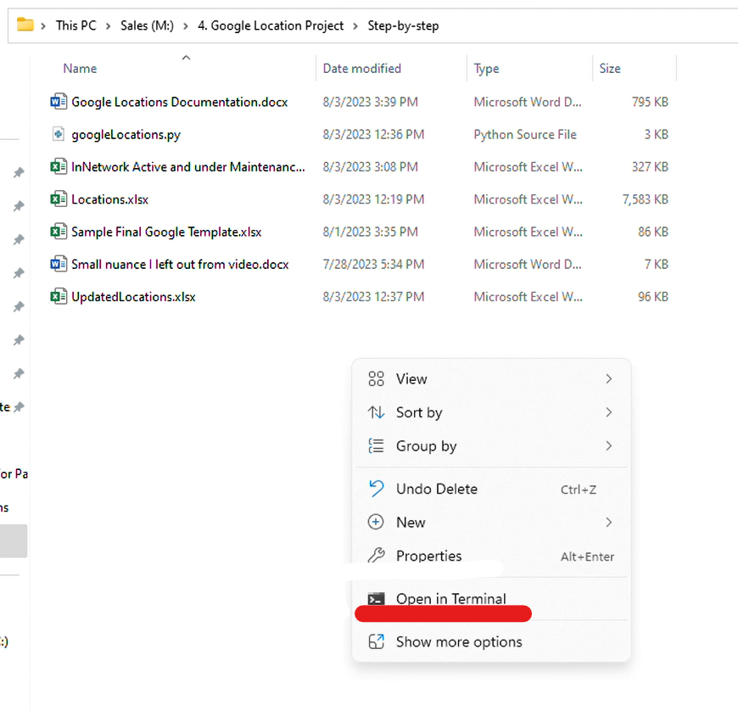**

**Once you open terminal, type one of the following commands to compile and run the python program with “py googleLocations.py” or “python3 googleLocations.py” or “python googleLocations.py”. Once again the command depends on how your operating system labels python. Here are examples of each. Only one of them will work for you.**

****

 

**Once you compile and run the python file with this command, it should output a new Excel File called UpdatedLocations.xlsx in the same folder as googleLocations.py and Locations.xlsx. googleLocations.py essentially takes the business hours from the hours sheet and parses each string to output a timing format following HH:MMAM-HH:MMPM into 7 different columns for each respective day**

* 1. ***Using UpdatedLocations.xlsx***

**Once UpdatedLocations.xlsx is outputted in the folder, open it, and it should contain all the information in the ‘hours’ sheet, but bolded. As you will notice, now all the times listed under the columns Sunday-Saturday follow the format HH:MMAM-HH:MMPM as Google wants them to be. Copy the columns Sunday, Monday, Tuesday, Wednesday, Thursday, Friday, and Saturday, and clear all formats. Then copy those columns again and input them into columns W-AC of the ‘hours’ sheet. Once you input this, all the business hours in ‘sheet1’ will be filled accordingly using Excel code.**

* 1. ***Using ‘sheet1’***

**Now that ‘sheet1’ contains all the information you need copy all the data in it and save it as a new Excel File. Copy all the data in ‘sheet1’ with Ctrl + A, then right click and paste Values (V) into a new Excel File (if you don’t paste with values each cell will contain code). Name this file with a name that is appropriate with what locations you’ve filtered. I’ve left an example in the folder called “InNetwork, Active and under Maintenance.xlsx”**

* 1. ***Uploading the document***

**Just to double check one more time, make sure that the new file aligns with Google’s Template. You can do this by checking the Excel file “Sample Final Google Template.xlsx” with the Excel file that you’ve saved. Now that it aligns, follow the steps in the preface to add the businesses into Google Business Manager in bulk!**